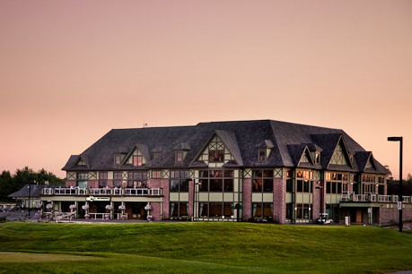
52nd Annual Golf Tournament
Wednesday, June 13th, 2018 at Deer Creek Golf Course
2700 Audley Road N., Ajax, ON L1Z 1T7

DETAILS
- Registrations due by May 31st | - Registration open 10:30 am
- 4 person scramble | - BBQ lunch at registration
- IBAO Members & Associates | - Shot gun start 12:30 pm
- Wine raffle, 50/50 | - Dinner & prizes at 6 pm

For more information email
Quincy quincy@dgsmithinsurance.com or Beverley bmartonfi@sentinelrisk.ca
Golfer Name | Company | Email or Phone
 |  |  | $200
 |  |  | $200
 |  |  | $200
 |  |  | $200
 |  |  | TOTAL $
Number of dinner only attendees ______ please add $50 per person
Please make cheques payable to: Insurance Brokers Association of Durham Region.
Send your registration to:
DG Smith Insurance c/o Quincy Huntley
4 Banff Rd. # 2, Uxbridge, ON L9P 1S9
Door prize donations appreciated!

